Sorting algorithms analysis

Temporal complexity

Merge Sort
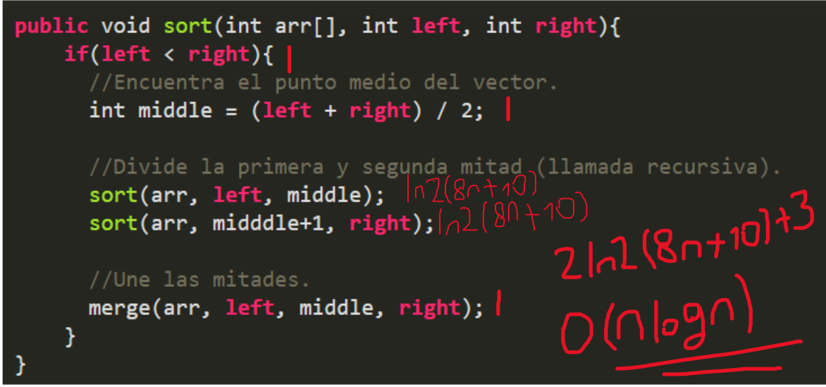
Figure 1 Algorithm took from https://platzi.com/tutoriales/1469-algoritmos/4260-merge-sort-en-java/

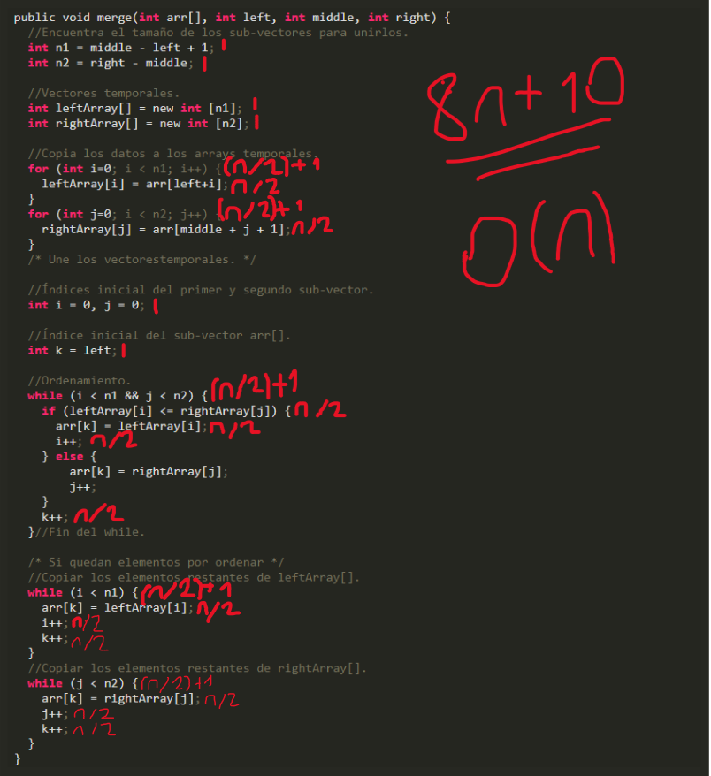
Figure 2 Algorithm took from https://platzi.com/tutoriales/1469-algoritmos/4260-merge-sort-en-java/

Quick Sort
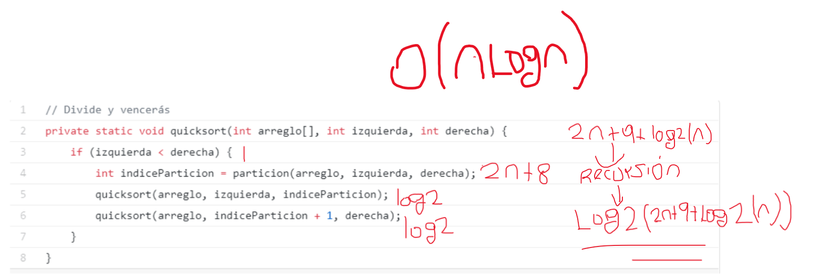
Figure 3 Algorithm took from https://parzibyte.me/blog/2019/12/26/quicksort-java-ordenar-arreglos/

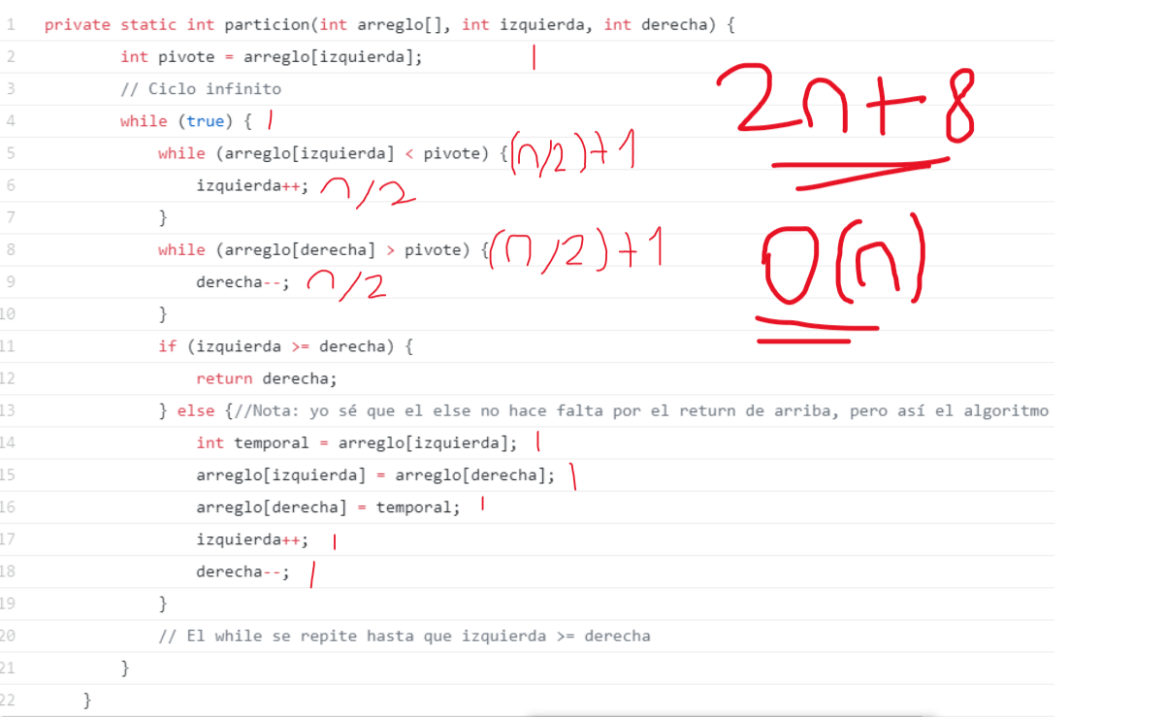
Figure 4 Algorithm took from https://parzibyte.me/blog/2019/12/26/quicksort-java-ordenar-arreglos/

Space complexity
Merge sort (sort part)
Type | Variable | Atomic values quantity
Input | Arr  Left  right | N  1  1
Auxiliar | Middle | 1
output |  | 0
Total Complexity | N+4 | 0(n)

Merge sort (merge part)
Type | Variable | Atomic values quantity
Input | Arr  Left  Right  Middle | N  1  1  1
Auxiliar | N1  N2  LeftArray  RightArray  I  k | 1  1  n/2  n/2  1  1
output |  | 0
Total complexity | 2n+7 | 0(n)
Quick sort (main part)
Type | Variable | Atomic values quantity
Input | Arreglo  izquierda  derecha | N  1  1
Auxiliar | Indice Particion | 1
output |  | 0
Total Complexity | N+3 | O(n)

Quick sort (partition part)
Type | Variable | Atomic values quantity
Input | Arr  Left  right | N  1  1
Auxiliar | pivote | 1
output |  | 0
Total Complexity | N+3 | O(n)

